What is the Naive Bayes Algorithm?

It is an algorithm that learns the probability of every object, its features, and which groups they belong to.

The Naive Bayes Algorithm comes under supervised learning and is mainly used to solve classification problems.

P(H|E) = (P(E|H} * P(H))/P(E)

In the above equation,

* P(H|E) denotes how event H happens when event E takes place.
* P(E|H) represents how often event E happens when event H takes place first.
* P(H) represents the probability of event X happening on its own.
* P(E) represents the probability of event Y happening on its own.

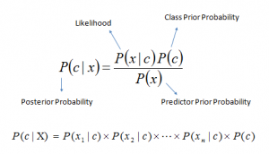

### **Conditional Probability**

Conditional probability is a subset of probability. It reduces the probability of becoming dependent on a single event.

P(Y|A) = P(X and Y) /P(X)

Formula-



Example-

